Assignment-2

1. IPv4 vs. IPv6
Internet Protocol (IP) is a fundamental protocol used in computer networking to identify devices and enable communication between them across networks. Two main versions of the Internet Protocol are currently used: IPv4 (Internet Protocol version 4) and IPv6 (Internet Protocol version 6). IPv4 has been the dominant protocol used since the early days of the internet, but due to the rapid growth of internet-connected devices, IPv6 was introduced to overcome the limitations of IPv4.
IPv4 uses a 32-bit address format which allows approximately 4.3 billion unique addresses. An IPv4 address is typically written in dotted decimal notation such as 192.168.1.1. The address consists of four numbers separated by periods, and each number ranges from 0 to 255. IPv4 addresses are divided into network and host portions which help routers determine where packets should be delivered.
However, as the internet expanded globally, the number of available IPv4 addresses became insufficient. Billions of devices including smartphones, computers, IoT devices, and servers require unique addresses to communicate on the internet. As a result, techniques such as Network Address Translation (NAT) were developed to conserve IPv4 addresses, but these solutions only temporarily delayed address exhaustion.
IPv6 was developed by the Internet Engineering Task Force (IETF) to solve this problem. IPv6 uses a 128-bit addressing scheme which allows an extremely large number of unique addresses. An IPv6 address looks different from IPv4 and is written in hexadecimal format such as 2001:0db8:85a3:0000:0000:8a2e:0370:7334. This larger address space ensures that the internet can continue to grow without running out of addresses.
IPv6 also includes several improvements over IPv4. These include simplified packet headers, improved routing efficiency, built‑in support for security through IPsec, and better support for mobile devices. Additionally, IPv6 allows devices to automatically configure their own IP addresses through a process called Stateless Address Autoconfiguration (SLAAC).
Although IPv6 adoption has been increasing steadily, IPv4 is still widely used today. Many networks currently operate using both IPv4 and IPv6 simultaneously, a process known as dual stack implementation. Over time, IPv6 is expected to replace IPv4 as the primary protocol used for internet communication.

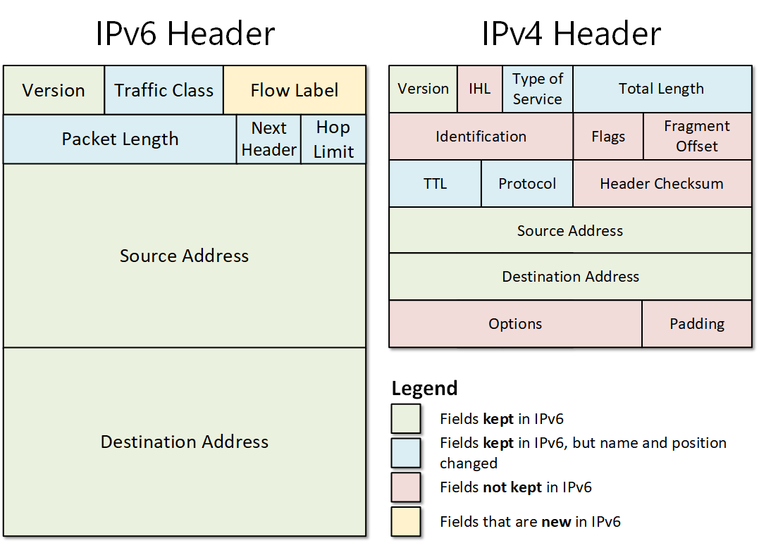

2. Subnetting Basics
Subnetting is a networking technique used to divide a large network into smaller, more manageable sections called subnets. It is commonly used in both enterprise and organizational networks to improve performance, security, and efficient use of IP address space. By breaking a network into smaller parts, administrators can better organize and control network traffic.
In any IP network, devices communicate using IP addresses that contain both network and host components. The network portion identifies the overall network, while the host portion identifies a specific device within that network. Subnetting works by borrowing bits from the host portion of an IP address and using them to create additional network segments.
For example, consider a network with the address 192.168.1.0/24. The /24 notation represents the subnet mask, which indicates that the first 24 bits of the address represent the network portion. This network can support up to 254 usable host addresses. If the organization wants to divide this network into smaller networks, subnetting can be applied by increasing the subnet mask to /25, /26, or /27 depending on the required number of subnets.
Subnetting provides several advantages. One important advantage is improved network performance. In large networks, broadcast traffic can become excessive and reduce efficiency. By dividing the network into smaller subnets, broadcast traffic is limited to each subnet, reducing congestion.
Another benefit of subnetting is enhanced security. Network administrators can isolate sensitive departments or systems within specific subnets, reducing the risk of unauthorized access. For instance, the finance department, human resources systems, and server infrastructure can all be placed in separate subnets.
Subnetting also improves network management. Administrators can more easily troubleshoot network problems and control traffic between different departments or network segments. Routers are typically used to connect different subnets and manage the routing of packets between them.
In modern networking environments, subnetting is an essential skill for network engineers. It helps organizations efficiently use their IP address allocations and design scalable, well-structured networks that can grow as organizational needs expand.
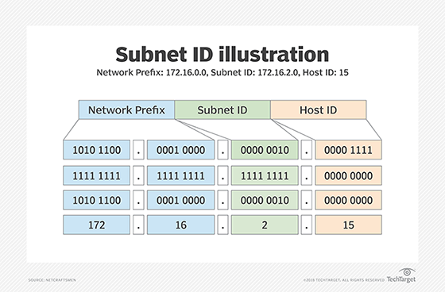

3. Network Address Translation (NAT)
Network Address Translation (NAT) is a technique used in networking to allow multiple devices within a private network to share a single public IP address when accessing the internet. NAT is commonly implemented in routers and is widely used in home networks, corporate environments, and internet service provider infrastructures.
Private networks typically use private IP address ranges such as 192.168.0.0/16, 10.0.0.0/8, or 172.16.0.0/12. These addresses are not routable on the public internet. Instead, they are used internally within organizations or homes. When a device inside the private network attempts to access the internet, NAT translates the private IP address into a public IP address before the packet is sent to the external network.
The process works as follows. When a device such as a laptop sends a request to access a website, the packet initially contains the device’s private IP address. The NAT-enabled router replaces the private IP address with its own public IP address and forwards the packet to the internet. When the response is received from the website server, the router translates the public IP address back into the original private IP address and sends the response to the correct device inside the network.
There are different types of NAT implementations. Static NAT maps a single private IP address to a specific public IP address. Dynamic NAT uses a pool of public IP addresses and assigns them to devices as needed. Port Address Translation (PAT), also known as NAT overload, allows many devices to share a single public IP address by using different port numbers.
NAT provides several advantages. One major advantage is conservation of IPv4 addresses. Since IPv4 addresses are limited, NAT allows many devices to operate behind a single public IP address. Another benefit is improved security. Devices within the private network are not directly exposed to the public internet, making it more difficult for attackers to access internal systems.
Despite its benefits, NAT also introduces some challenges. Certain applications such as peer-to-peer communication, VoIP, and online gaming may require special configurations like port forwarding to function correctly. Nevertheless, NAT remains a fundamental technology used in modern networking environments.
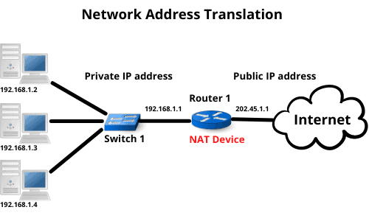

4. Wireless and Wired Networks
Computer networks can be broadly classified into wired networks and wireless networks based on the medium used for communication. Both types of networks play a critical role in modern communication systems and are used in homes, businesses, educational institutions, and large enterprises.
Wired networks use physical cables to connect devices together. The most common type of wired networking technology is Ethernet. Ethernet cables connect devices such as computers, switches, and routers to create a stable and reliable network infrastructure. Wired networks are known for their high speed, low latency, and consistent performance.
One of the primary advantages of wired networks is reliability. Since communication occurs through physical cables, the connection is less susceptible to interference from external factors such as walls, electronic devices, or environmental conditions. Wired networks are commonly used in offices, data centers, and enterprise environments where stable connectivity is essential.
However, wired networks also have some limitations. The use of cables restricts mobility, meaning devices must remain physically connected to the network infrastructure. Installation of cables can also be complex and expensive in large buildings or older infrastructure.
Wireless networks, on the other hand, use radio waves to transmit data between devices without requiring physical cables. The most widely used wireless networking technology is Wi‑Fi. Wireless access points or routers transmit signals that allow devices such as smartphones, laptops, and tablets to connect to the network.
Wireless networks offer several advantages including flexibility and mobility. Users can move freely within the coverage area while remaining connected to the network. This makes wireless networking ideal for homes, universities, public spaces, and workplaces that require mobility.
Despite these advantages, wireless networks may experience interference, signal loss, or reduced speeds compared to wired networks. Factors such as distance from the router, obstacles like walls, and the number of connected devices can affect wireless performance.
In many modern environments, organizations use a combination of both wired and wireless networks. Wired connections are used for critical systems such as servers and workstations that require high reliability, while wireless networks provide convenient connectivity for mobile devices. This hybrid approach ensures both performance and flexibility within the network infrastructure.
